2.1 Process Model

The elements of the project are as shown:

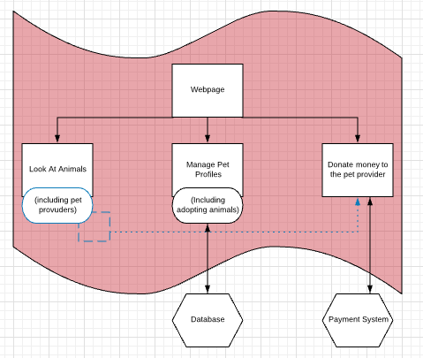

Webpage: The homepage of the website. The website will be publicly accessible and contain the following interactable elements

1. Look At Animals – This is the ability to browse all of the available pets.
2. Manage Pet Profiles – This is the ability to modify and add pet profiles.
3. Donate – At any time a visitor to the website is able to donate money to a specific pet provider.

Database: The database we will be using is Firebase. An API will be provided to us so we can communicate with the Firebase cloud.

Payment System: For the launch of the website we will be using PayPal. The PayPal API, which can be obtained via a PayPal business account, will allow us to send payment information to PayPal, where this will process the payment.

2.3 Organizational Interfaces

1. Firebase

Firebase is a mobile and web application development platform. We will be utilizing it as our database and hosting environment.

1. PayPal

PayPal is an online payment system. We will be utilizing it for processing the donations that any visitor to the site makes to a specific pet provider.

2.4 Project Responsibilities

Major Functions:

1. Database setup
2. Database coding
3. Website hosting setup
4. HTML
5. GUI design
6. GUI coding
7. Class design and coding
8. PayPal API integration

Major Activities:

1. Unit testing
2. Integration testing
3. Regression testing
4. System testing
5. Client correspondence

Task Distribution Chart

|  |  |  |  |
| --- | --- | --- | --- |
| Jon | Ellen | Sam | Lifan |
| - Class design and coding  - Database coding  - Unit testing | - GUI design  - GUI coding  - System testing | -HTML  - PayPal API Integration  - Integration testing | - Database Setup  - Website hosting setup  - Regression testing |